**FROM:**

M/N Wagner Mogga 1/C                                     17 SEPTEMBER, 2018

United States Merchant Marine Academy

PO Box 499

Kings Point, NY, 11024-1699

**TO:**

Captain Peter Kahl

Engineering Department

Fulton Hall

Kings Point, NY 11024-1699

SUBJ: Economic Evaluation and Justification

REF: Economic Evaluation and Justification: 10 SEP, 2018

ENCL: Economic Evaluation and Justification Including References.

* Team Prestige Coastwide is working on and researching the design for an offshore wind turbine installation vessel, with characteristics that are approximately 70% of the German Built  Heavy Lift Vessel “The Brave Tern.”
* The Economic Evaluation and Justification provides an estimate of the acquisition costs  and operating costs for Prestige Coastwides’ heavy lift vessel, The Gilded Lady. Using various techniques such as ratiocination and net present value calculations used predominantly in engineering economics our team has derived an analysis for both a new build vessel as well as a conversion vessel. Based on our research an average number of man hours was predicted to be 75 MH/ton.
* This document represents all of our own work in accordance with the regulations in place at the United States Merchant Marine Academy.

Very respectfully,

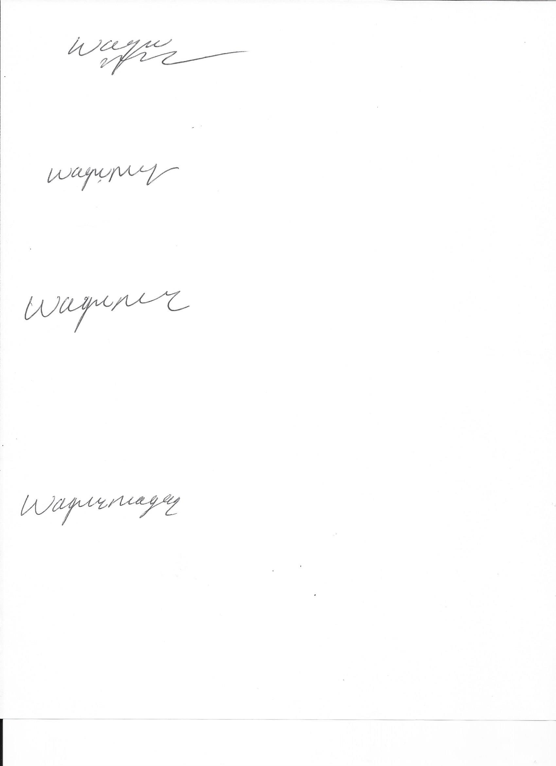

Midshipman Wagner Mogga 1/C

Team Leader

Prestige Coastwide

**Background:**

Our vessel, the *Gilded Lady*, a wind turbine installation vessel, must be constructed in a domestic shipyard in order to be considered a Jones Act compliant vessel. Alternatively, a U.S. flagged ship may be purchased and converted to meet the owner’s requirements. This economic justification will consider both options. The economic justification will include the initial capital cost of building or converting the vessel, and also the operational costs over a 30 year life span. Operational costs include costs associated with manning the vessel, fuel usage, and routine dry dock and shipyard costs.

***Brave Tern* Characteristics:**

|  |  |
| --- | --- |
| Gross Tonnage | 15,328 tons |
| Deadweight | 9,033 tons |
| Length Overall | 131.73 m |
| Breadth Extreme | 39 m |

Our ship, the *Gilded Lady*, will be approximately 70% of the size of the Brave Tern. Cost estimations calculated in this report will use the characteristics listed below.

***Gilded Lady* Characteristics:**

|  |  |
| --- | --- |
| Gross Tonnage | 10,730 tons |
| Deadweight | 6,323 tons |
| Length Overall | 92 m |
| Breadth Extreme | 27 m |

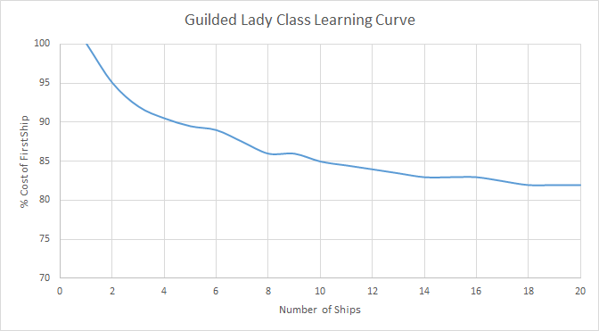

The above learning curve is the projection over time of the decrease in the cost of production related to the number of Gilded Lady Class ships produced. The expectation when building a class of ships is that as the shipyard is familiar with the class they number of deficiencies and rework during the construction process decreases and therefore the cost of building the ship goes down. The cost of rework is related to both the material wasted and the man hours wasted so the ships funds are spent more efficiently with familiar workers. The learning curve illustrated above represents the predicted path for the Gilded Lady Class ships from the knowledge of both the team members’ shipyard experiences and the *1995 Ship Production Symposium; Commercial Competitiveness For Large and Small North American Shipyards”*. Included in this report are typical curves for % cost of unit vs unit number, the learning curve from the LSD-41 class vessels, and a half life graph with the defect index. These typical curves for North American shipyards and comparing the specificity of the LSD to the Gilded Lady design, the learning curve above was concluded.

**Operational Costs:**

**Manning Costs**

Specific manning requirements are determined by the Officer in Charge, Marine Inspection (OCMI). The OCMI takes into account applicable laws, CFR regulations, emergency situations, size and type of vessel, installation equipment, cargo carried, etc. According to CFR 46- Pt 15, our vessel is considered an offshore supply vessel since it is “a motor vessel that regularly carries goods, supplies, individuals in addition to the crew, or equipment in support of exploration, exploitation, or production of offshore mineral or energy resources.”

In accordance with the Safe Manning Certificate contained in the U.S Code of Federal Regulations (CFR 46- Pt 15), the *Gilded Lady* will have a crew size of 25 full-time employees. CFR 46- Pt 15 requires a master and two mates (for an offshore supply vessel of 100 gross tons or more). It requires that at least 65 percent of the deck crew of vessels over 100 gross tons, excluding individuals serving as officers, must be able seamen. Two riggers, two crane operators, and a jacking master will also be required to safely support the cargo being carried (wind turbines) and operate the installation equipment.

The positions and costs to man and operate the vessel on a year-round permanent basis are shown in the table below.

|  |  |  |
| --- | --- | --- |
| Number | Description | Base Salary (USD per year) |
| 1 | Master | 280,000 |
| 2 | 1st Mate | 196,000 |
| 3 | 2nd Mate | 140,000 |
| 4 | 3rd Mate (Night) | 154,000 |
| 5 | Seaman | 70,000 |
| 6 | Seaman | 70,000 |
| 7 | Seaman | 70,000 |
| 8 | Chief Engineer | 234,000 |
| 9 | 1st Engineer | 182,000 |
| 10 | 2nd Engineer | 143,000 |
| 11 | 3rd Engineer (Night) | 143,000 |
| 12 | Oiler | 120,000 |
| 13 | Oiler | 120,000 |
| 14 | Oiler | 120,000 |
| 15 | Chief Steward | 80,000 |
| 16 | Steward | 50,000 |
| 17 | Steward | 50,000 |
| 18 | Chief Cook | 70,000 |
| Number | Description | Base Salary (USD per year) |
| 19 | Cook Asst (Day) | 50,000 |
| 20 | Cook Asst (Night) | 45,000 |
| 21 | Jacking Master | 120,000 |
| 22 | Crane Operator | 85,000 |
| Number | Description | Base Salary (USD per year) |
| 23 | Crane Operator | 85,000 |
| 24 | Rigger | 50,000 |
| 25 | Rigger | 50,000 |
|  | Total | 2,777,000 USD per year |

*\*Values are taken from U.S. Jones Act Compliant Offshore Wind Turbine Installation Vessel Study.\**

We estimate that it will cost 2.77 million dollars a year to man the vessel, including vacation, overtime, and base salary. We will multiply by 1.15 to account for crewing costs such healthcare, dental, and retirement matches. This value also does not include temporary support crew members. We will use $3,194,000 in the economic analysis below.

(2,777,000)*(1.15)=$3,193,550

**Fuel Costs**

In order to calculate fuel costs, the fuel price was averaged from July 2nd, 2018 to August 31st, 2018. We found the average MDO cost per metric ton to be 672.64 USD according *Bunkerindex.com.* The *Gilded Lady* will be diesel electric, requiring approximately 17,000 KW. We estimate that the ship will consume 30 MT/day while underway, and 5 MT/day while in port or jacked up. When the vessel is jacked up using the cranes, fuel consumption is approximately 8 MT/day. Although these values may seem high for a 92 ft. vessel, our main propulsion system and cranes will both be using power from the electrical generation system.

During our first year of wind turbine installation, we plan to install 6 turbines over a period of four months, from August to November. While the *Gilded Lady* is not installing wind turbines, it will be performing maintenance on the previously installed turbines and will also be available for projects in the south in the winter time. We will assume the vessel will be underway working for approximately 8 months (⅔) of the year. Out of these 8 months, 4 months will be elevated using the cranes to install the turbines. The remaining for months is allotted for transferring equipment, moving between wind turbines, and traveling to different farms for various installation projects. The remaining four months (¼ of the year) the vessel will be in port, in the shipyard, or at standby while elevated. We will use $3,500,000 as the total cost of fuel per year in the economic analysis.

|  |  |  |  |  |
| --- | --- | --- | --- | --- |
| **Fuel Costs** | **Time (Days)** | **Fuel Cost (USD/ MT)** | **Fuel Consumption (MT)** | **Total Cost** |
| In Port | 121 | 673 | 5 | 407,165 |
| Elevated-Using Cranes | 121 | 673 | 8 | 651,464 |
| Underway | 121 | 673 | 30 | 2,442,990 |
|  |  |  | Total Cost: | $3,501,619 |

*\*Note: These fuel values were approximated from the rated fuel consumption of the Brave Tern. Since the Gilded Lady is 70% in size, it will require less fuel to power the vessel. The BraveTern is rated at 42 MT/day while underway, therefore 30 MT/day at 70% for the Gilded Lady.\**

**New Build Capital Costs:**



The Capital Cost for the construction of the Gilded Lady was based off of the Gross Tonnage estimated by 70% of the Brave Tern’s weight. Using this tonnage and knowledge of the cost per ton of the raw materials that a ship consists of the cost of raw material could be calculated. In addition, equipment cost was included based off of the average cost per ton of equipment such as large ticket items like the main engine, propeller/shaft and so on. The Gilded Lady will be the first of its class and therefore a 20% overhead cost was included to accommodate for the indirect costs of the shipbuilding process. These numbers produced a Total Material cost of $60,517,200.

The Manning Cost was also estimated off of the predicted gross tonnage of the ship. Based on research an average number of man hours was predicted to be 75 MH/ton. These man hours were then multiplied by the cost of a man hour, or the workers’ pay. An average of workers’ pay in the yard was concluded to be $40/hour considering that some workers are paid more or less depending on their specialty. The value per hour for the shipyard worker was taken from the Norfolk Naval Shipyard salaries. Although a naval shipyard’s pay rates are different than that of a commercial shipyard, because commercial companies are private this was the most educated value the team could collect. Due to the learning curve an estimated overhead of manning costs is predicted to be 25% for rework purposes.

From SWBS numbers a complexity factor of 2 was assigned to this ship because it is the first of its kind to be built in the United States. The Contract Design was assigned a cost of $400/ton which resulted in a total cost of $4,292,000. The sum of the Material Cost, Manning Cost, and Contract Cost is $205,801,400.

**New Build Maintenance Costs:**

We estimate that within the first five years of operation, maintenance costs will be extremely low that they are negligible. After the first dry-dock, we assume that each year maintenance costs will total approximately 1 million dollars. Although this number is high for a small vessel, our equipment is specialized and complex, therefore we assume maintenance costs will be higher than average. Every five years, when the ship is dry docked, we estimate the cost to be 3 million dollars.

**Conversion Capital Costs:**

The issue with building or converting a wind turbine installation vessel (TIV) in the US is the lack of experience the shipyards in the country have with building or converting TIVs and the cost it will take for the shipyards to learn how to build/convert these vessels. A Department of Energy (DOE) assessment found that “our industry surveys indicate that US built vessels would cost 60-200% more than comparable Asian built vessels”. The ship the *Gilded Lady* is based on the ship called the *Brave Tern.* The *Brave Tern* was converted for 160.2 million dollars in 2012. We can expect the price to convert a ship of similar size in a US built ship to cost anywhere from 256.32-320.4 million dollars. Since the *Gilded Lady* is 70 percent of the size of the *Brave Tern*, a conversion would be expected to cost about 179.424-224.28 million dollars.

The DOE assessment also goes on to say “creative strategies are needed in order to enable US shipyards to reduce costs and gain experience while complying with Jones Act constraints. For example, some yards have increased their competitiveness while meeting domestic content requirements using “ship-in-a-box” strategies which see modular components of vessels constructed in Asian yards, with these modules assembled in the US. Reducing the premium of US yards to 25-40% over their Asian peers with such strategies might prove sufficient to bridge the gap and enable developers to utilize US built TIVs”. If a ship converted in the US can use these techniques, the price would go down significantly to about 200.25-224.28 million dollars and the ship would be a lot more feasible to build. This means the *Gilded Lady* would cost about 140.175-156.996 million dollars. This would put the price of a conversion in a much more feasible and practical price range. This price range will take time to get to because American shipyards will need time to learn how to convert and build these complex vessels.

**Conversion Maintenance Costs:**

Since the vessel will only be converted, we estimate that the vessel will accumulate 1 million dollars’ worth of maintenance costs annually, starting at the time of the conversion. Like the new build, we also approximate the 5 year dry docking cost to be 3 million dollars.

**Salvage Value:**

According to the article “UAE: Fred. Olsen Windcarrier Brave Tern Launched” in *World MaritimeNews*, the Brave Tern weighs 14,800 tons. Since the *Gilded Lady* is 70% of the size, we estimate that it will weigh 10,360. Beached vessels are valued according to their LDT(Light Displacement). We multiplied the weight of the ship by the value the beaching company pays the ship owner for its steel. We assumed that our ship would be scrapped in India considering it has the world’s largest beaching facility. Our salvage value was found to be 4,299,400 million. We will use $4,000,000 in our economic analysis below. We chose to round down since the ship is priced off of Light Displacement our calculated value is likely to be slightly greater than the actual value.

|  |  |  |
| --- | --- | --- |
| **LDT (Approximate)** | **Demo Cost (USD/LDT)** | **Salvage Value (USD)** |
| 10,360 | 415 | $4,299,400.00 |

**Analysis:**

Our MARR value, a combination of the inflation rate and rate of return, is 5%. Since we estimated the conversion will only have a lifespan of 15 years, and we must compare the values over the same lifespan, we will assume the conversion must be done again after 15 years.

Treasury Bond Rate over 30 years= 3.11%

Inflation Rate: 2%

MARR: 5%

|  |  |  |
| --- | --- | --- |
|  | **New Build** | **Conversion** |
| **First Cost** | 205,801,000 | 156,996,000 |
| **Annual: Operating Cost (Fuel)** | 3,500,000 | 3,500,000 |
| **Annual: Operating Cost (Manning)** | 3,194,000 | 3,194,000 |
|  |  |  |
|  | **New Build** | **Conversion** |
| **Every 5 Years: Periodic Drydocking** | 3,000,000 | 3,000,000 |
| **Annual: Maintenance** | 1,000,000 (starting at end of year 5) | 1,000,000 |
| **Salvage Value** | 4,000,000 (scrap value) | 4,000,000 (scrap value) |
| **Life, Years** | 30 | 15 |

**Present Worth of New Build:**

|  |  |  |  |  |
| --- | --- | --- | --- | --- |
| **New Build:** |  |  |  |  |
|  | Cost | Function | Value | Total |
| Initial | $205,801,000 | Present Value | 1 | $205,801,000 |
| Annual Fuel and Manning | $6,694,000 | (P/A, 5%, 30) | 15.3700 | $102,886,780 |
| Annual M&R (after year 5) | $1,000,000 | (P/A, 5%, 26)*(P/F, 5%, 4) | 11.8265 | $11,826,477 |
| Drydock | $3,000,000 | (P/F, 5%, 5) | 0.7835 | $2,350,500 |
| Drydock | $3,000,000 | (P/F, 5%, 10) | 0.6193 | $1,857,900 |
| Drydock | $3,000,000 | (P/F, 5%, 15) | 0.418 | $1,254,000 |
| Drydock | $3,000,000 | (P/F, 5%, 20) | 0.3769 | $1,130,700 |
| Drydock | $3,000,000 | (P/F, 5%, 25) | 0.2953 | $885,900 |
| Salvage | -$4,000,000 | (P/F, 5%, 30) | 0.231 | -$924,000 |
|  |  |  | PW= | $327,069,257 |

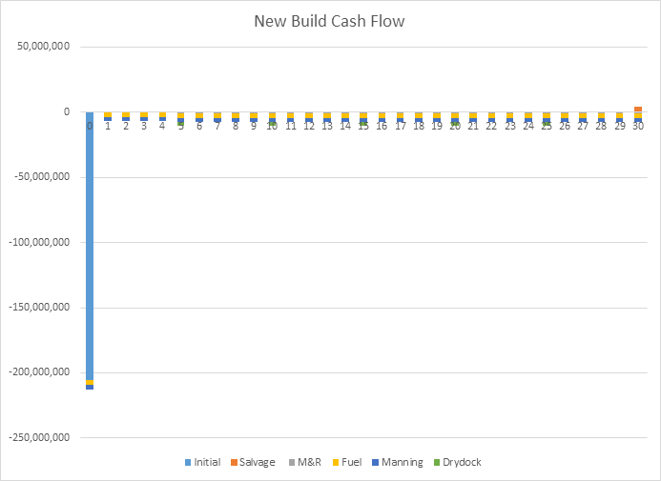

**Equation:**

PW= -205,801,000-3,500,000(P/A, 5%, 30)-3,194,000(P/A, 5%, 30)-3,000,000(P/F, 5%, 5)-3,000,000(P/F, 5%, 10)-3,000,000(P/F, 5%, 15)-3,000,000(P/F, 5%, 20)-3,000,000(P/F, 5%, 25)-1,000,000(P/A, 5%, 26)(P/F, 5%, 4)+4,000,000(P/F, 5%, 30)

= -327,070,000

**Present Worth of Conversion:**

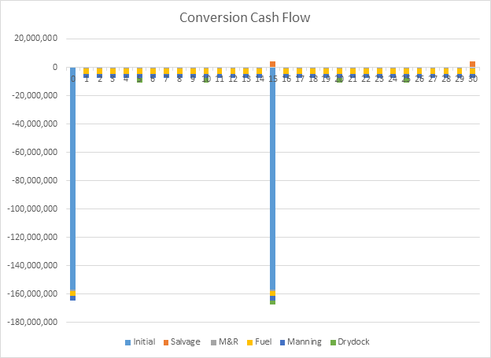

|  |  |  |  |  |
| --- | --- | --- | --- | --- |
| **Conversion:** |  |  |  |  |
|  | Cost | Function | Value | Total |
| Inital | $156,996,000 | Present Value | 1 | $156,996,000 |
| Annual | $7,694,000 | (P/A,5%,30) | 15.37 | $118,256,780 |
| Drydock | $3,000,000 | (P/F, 5%, 5) | 0.7835 | $2,350,500 |
| Drydock | $3,000,000 | (P/F, 5%, 10) | 0.6193 | $1,857,900 |
| Drydock | $3,000,000 | (P/F, 5%, 15) | 0.418 | $1,254,000 |
| Drydock | $3,000,000 | (P/F, 5%, 20) | 0.3769 | $1,130,700 |
| Drydock | $3,000,000 | (P/F, 5%, 25) | 0.2953 | $885,900 |
| New Conversion | $156,996,000 | (P/F, 5%, 15) | 0.418 | $65,624,328 |
| Salvage | -$4,000,000 | (P/F, 5%, 15) | 0.418 | -$1,672,000 |
| Salvage | -$4,000,000 | (P/F, 5%, 30) | 0.231 | -$924,000 |
|  |  |  | PW= | $345,760,108 |

**Present Worth Equation:**

PW= -156,996,000-3,500,000(P/A, 5%, 30)-3,194,000(P/A, 5%, 30)-156,996,000(P/F, 5%, 15)

-3,000,000(P/F, 5%, 5)-3,000,000(P/F, 5%, 10)-3,000,000(P/F, 5%, 15)-3,000,000(P/F, 5%, 20)-3,000,000(P/F, 5%, 25)-1,000,000(P/A, 5%, 30)+4,000,000(P/F, 5%, 15)+4,000,000(P/F, 5%, 30)

=-345,760,000

**Conclusion:**

A converted ship would have a shorter life span and once it’s short life span has been expended there is little to no salvage value above the value of the recycled steel. It is expected that the converted ship would last an additional fifteen years after the conversion. If Prestige Coastwide were to continue work in the offshore wind turbine industry after these ten years it would need to spend money on either another conversion or a new build. Over a thirty year period the cost would be greater than the new build due to the major cost at the ten year mark.

A new build would have a greater upfront cost than a converted ship due to the purchasing of new equipment and raw materials, and a longer shipyard period. However, because of the materials being used are new it is expected that less maintenance will be required on a yearly basis and the shipyard periods will be less costly than the conversion. In addition the lifespan of the ship would be thirty years rather than fifteen. This would result in a major cost savings at the ten year mark when compared to the converted ship option.

Prestige Coastwide has decided with the above considerations in mind that a new build would be a more cost effective option over the next thirty years. Although the initial cost of a conversion is less than that of a new build, the maintenance costs would be greater on an annual basis and the salvage value would be less. These major factors are what account for the $50,000,000 difference upfront. The company is looking for a ship to last long term because of the projected increase in the offshore wind turbine industry.

**Sources:**

<http://www.marinetraffic.com/en/ais/details/ships/shipid:1614/mmsi:229044000/imo:9583782/vessel:BRAVE_TERN#c9j1dBOehkAMIwJg.99>

<https://tradingeconomics.com/commodity/steel>

<https://www.energy.gov/sites/prod/files/2013/12/f5/assessment_vessel_requirements_US_offshore_wind_report.pdf>

<https://www.researchgate.net/profile/Mark_Spicknall/publication/235160983_The_National_Shipbuilding_Research_Program_1995_Ship_Oroduction_Symposium_Paper_No_22_Past_and_Present_Concepts_of_Learning_Implications_for_US_Shipbuilders/links/5803f03a08ae23fd1b68a1b3/The-National-Shipbuilding-Research-Program-1995-Ship-Oroduction-Symposium-Paper-No-22-Past-and-Present-Concepts-of-Learning-Implications-for-US-Shipbuilders.pdf>

<https://www.focus-economics.com/commodities/base-metals/steel-usa>

<https://www.researchgate.net/publication/224904596_Cost_and_Man-Hour_Estimation_of_the_Production_of_Merchant_Ship_at_Design_Stage>

<http://thorconpower.com/costing/the-shipyard-model>

<https://www.indeed.com/cmp/Norfolk-Naval-Shipyard/salaries>

https://www.marinelink.com/news/economics-scrapping414382